Is God Calling You to A Deeper Relationship?
The Sabbath of Solitude and Silence
at Pacem In Terris
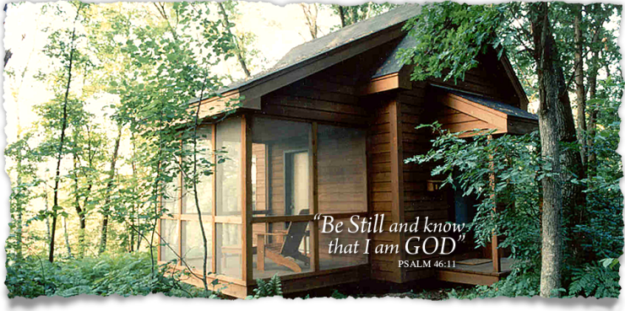
3 Day Silent Retreat
This experience is for the person wishing to take their faith journey deeper by spending a deliberate and purposeful time alone in silence and solitude with God. It is a time of sabbath rest, prayer, contemplation, journaling, waking, and being available in the presence of your Creator. It is a beautiful time away from cell phones, television, computers and other modern distractions. It is time spent simply and solely alone with God. God will restore your soul.

We will carpool together to the center as fellow pilgrims, then spend our 48 hours alone. This is open all men and women.
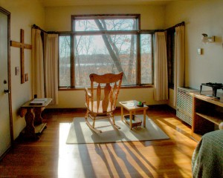
Dates: June 19-21, 2023

Total Cost is: $220.00
To reserve a spot, you must contact Pacem Directly at 763-444-6408, tell them you are with the First Lutheran Fargo Group. This is first come first served.
Contact: Rollie Johnson 235-7389

Solitude is thus the place of purification and transformation, the place of great struggle and the great encounter. Solitude is not simply a means to an end. Solitude is its own end. It is the place where Christ remodels us in His own image and frees us from the victimizing compulsions of the world. Solitude is the place of our salvation. Solitude is the place of conversion, the place where the old self dies and the new self is born, the place where the emergence of the new man and the new woman occurs. In solitude I get rid of my scaffolding: no friends to talk with, no telephone calls to make, no meetings to attend, no music to entertain, no books to distract, just me- naked, vulnerable, weak, sinful, deprived, broken- nothing. It is this nothingness that I have to face in my solitude. The Way of the Heart, Henri Nouwen

